

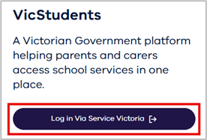
-

1
| Department of Education

To log in to the VicStudents portal, all users must use a Service Victoria (Service Vic) account.
Select the following link:
https://students.educationapps.vic.gov.au/s
/
.

Then select
Log in Via Service Victoria

•

If you already have a Service Vic account:
Sign in using your existing account details.
•

If you do not have a Service Vic account:
Follow the prompts to create your Service Vic account.
Then return to the VicStudents portal and log in using those details.
•

If you have used the VicStudents portal previously:
You will now need to log in using a Service
Vic account. Previous login methods are no longer supported.
If you experience any access issues, follow the Service Victoria account recovery options .

Enrolling your student is quick and easy using the device of your choice.
VicStudents Online Enrolment Parent/Carer Guide

Submit an enrolment application
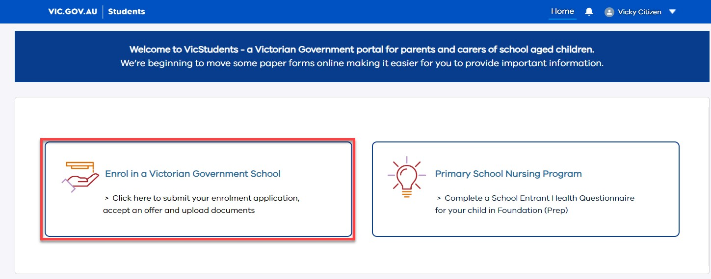
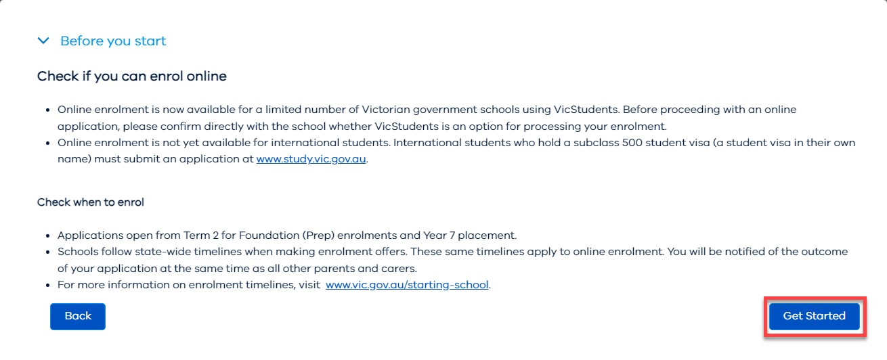
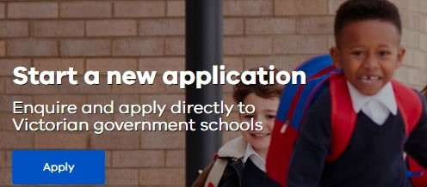
Before starting, have relevant digital documents ready to upload to your application eg. proof of address, proof of name and date of birth
- Select Enrol in a Victorian Government School from the homepage
- Read Before you start to check eligibility then select Get Started
- Select Apply from the Enrolment homepage
- Select New Student and answer the mandatory questions related to your student
- Read the Privacy Notice then select Continue
- Complete details for student, address, school and family sections 7. Select one to three school preferences
Note: Only some schools are available for online application
- Select I understand to acknowledge that only one school offer can be accepted
Note: Use the save button to save a draft and return later to complete and submit the application
- Upload relevant requested documents
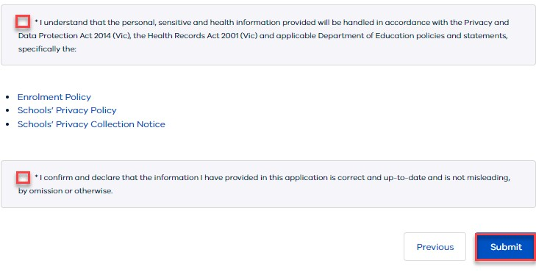
- Read Review and Declaration and check all details are complete and correct. Then tick the acknowledgements
Note: Once submitted enrolment application details cannot be changed
- Select Submit
- Read the review confirmation and select Proceed with Submission
- Select Close in the Application Submission screen to return to the VicStudents homepage
2 | Department of Education
Online Enrolment

View an application
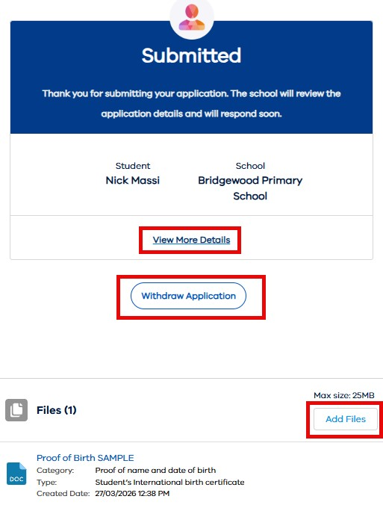
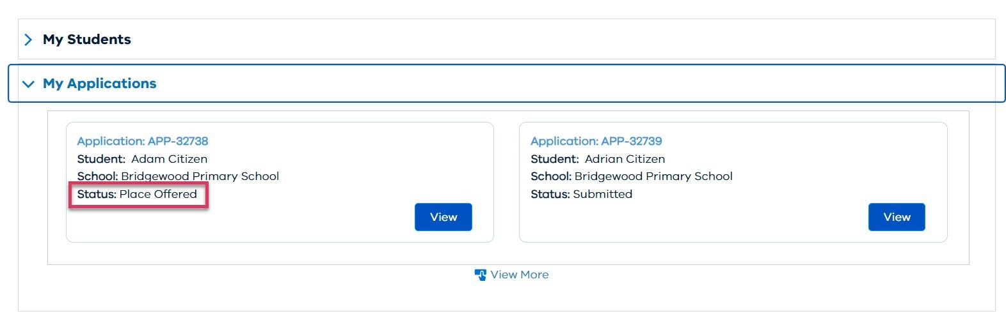
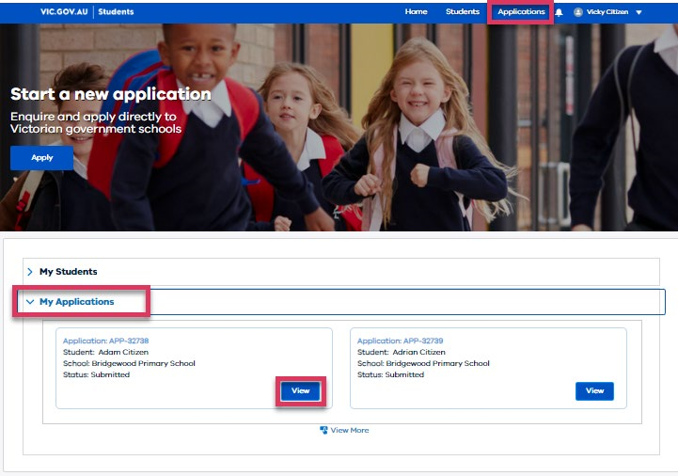
- Select Enrol in a Victorian Government School from the homepage. Then select Get Started
- Scroll down to the My Applications section, or click on Applications on top menu bar
- Select View to monitor and manage the relevant application
- Monitor the application by viewing the application details and status bar
  - Select View More Details to view application details
  - Select Add Files to add files to the application
  - Select Withdraw Application and enter a reason. This will change the status to Closed

Accept or do not accept an offer
IMPORTANT NOTE: All offers must be accepted via the portal.
When a school makes an offer, you will be notified via the VicStudents portal and by email.
Note: Your email will include a link to log in to the VicStudents portal.
- Navigate to the Enrolments homepage
- Scroll down to the My applications section
- Select View on an application with status ‘Place Offered’

3 | Department of Education

Online Enrolment

- Select Proceed with Acceptance to accept the enrolment offer. Or select Do Not Accept to decline the offer. (You will only be able to accept one school offer)
  - If selecting Do Not Accept, enter a reason and the application will be closed
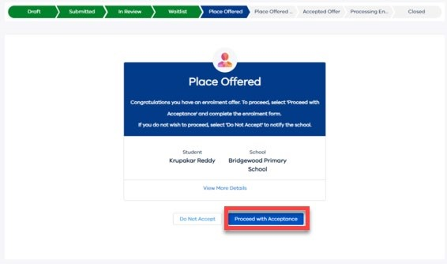
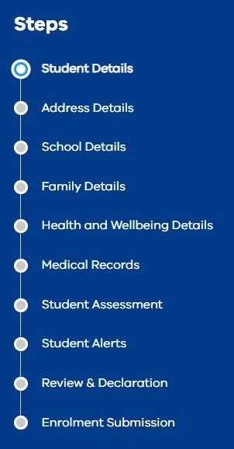
  - If selecting Proceed with Acceptance you can only accept one school offer. Select I understand to confirm and proceed
- Read the Privacy Collection Notice. Then select Continue to complete the online enrolment form
- Enter details for each section of the enrolment form
NOTE: Use the save button to save a draft and return later to complete and submit the enrolment form
- Upload relevant requested documents
- Read Review and Declaration and check all details are complete and correct
- Tick the confirmation boxes and select Submit
- Read the confirmation of review and select Accept Offer
NOTE: The student’s personal and health information will be shared with the school
- An email will be sent once the school finalises the enrolment application. You will also receive a notification via the VicStudents portal.

We are here to support you
If you have any questions regarding your student’s enrolment, contact the school. For information about this process, visit https://www.vic.gov.au/how-to-enrol-your-student-in-a-school
4 | Department of Education

Online Enrolment

